PROJECT TITLE HERE

REVIEW REPORT

Submitted by

**Group Member1 Name (Reg no.)**

**Group Member2 Name (Reg no.)**

**Group Member3 Name (Reg no.)**

Prepared For

**DATABASE SYSTEMS (CSE2004) – PROJECT COMPONENT**

Submitted To

**Dr. Anand Bihari**

**Assistant Professor (Sr)**

**School of Computer Science and Engineering**



**Abstract**

**Table of Contents**

1. Introduction 4

2. Project SCOPE 4

3. Literature Review 4

4. Project Resource Requirements 4

5. ER Diagram 4

6. Tables and Constraints 6

7. Project output 7

8. Conclusion and Future Scope 7

9. Work Break Down 7

10. Key Contacts and Stakeholders 7

11. References 7

12. REVIEW EVALUATION 7

# Introduction

Every educational institution focuses on reduction of malpractices during examinations and there by establish good standards that contribute towards optimized evaluation processes for their students. As a result the institution can gain credibility in the eyes of the industry by reducing the gap in terms of identifying the right candidate for the various opportunities available. The Malpractice Management System is one such system that focuses on effective utilization of resources towards malpractice management thereby catering towards evaluation process optimization for students and faculty.

**Motivation of the project:**

# Project SCOPE

Malpractice Management System aims at automation of the following processes

1. Malpractice Registration by faculty members
2. Assignment and communication of enquiry committee members
3. Status tracking of Reported malpractices by students
4. Auto email Generation about the reported malpractice to the proctors and parents of the concerned students
5. Report Generation on the malpractices reported for measuring the effectiveness of the examination conduction process.

# Literature Review

# Project Resource Requirements

## Software Resource Requirements

* Software used
  + Front end
  + Back end

# ER Diagram

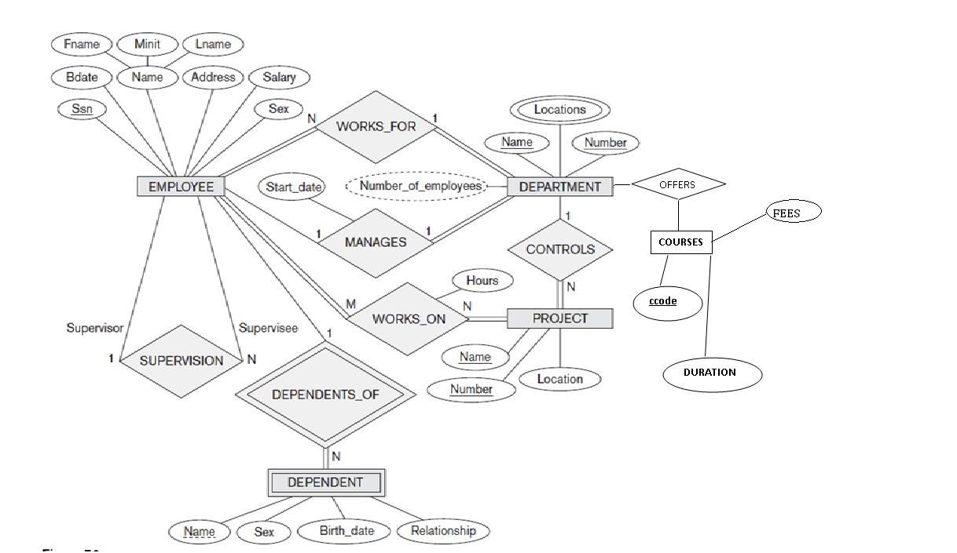

# Tables and Constraints





# Project output

# Conclusion and Future Scope

# Work Break Down

|  |  |  |
| --- | --- | --- |
| **Team Member Registration Number** | **Name** | **Work Assigned** |
| 1111111 | Member 1 | Functionality 3a,3b |
| 2222222 | Member 2 | Functionality 3c,3d |
|  |  |  |
|  |  |  |

# Key Contacts and Stakeholders

|  |  |  |
| --- | --- | --- |
| Name | Registration Number | Phone Number |
| Team Member 1 | 111111111 | 9962545500 |
| Team Member 2 | 222222222 | 8878878777 |
|  |  |  |

# References

# REVIEW EVALUATION

|  |  |  |  |  |  |  |
| --- | --- | --- | --- | --- | --- | --- |
| COMPONENT | MARKS | MEMBER 1 | MEMBER 2 | MEMBER 3 | MEMBER 4 | MEMBER 5 |
| Report | 10 |  |  |  |  |  |
| Project Implementation | 25 |  |  |  |  |  |
| Presentation | 15 |  |  |  |  |  |
| TOTAL | 50 MARKS |  |  |  |  |  |